Colorado Asphalt Pavement Association
Technical Resources Library
Rubbilization

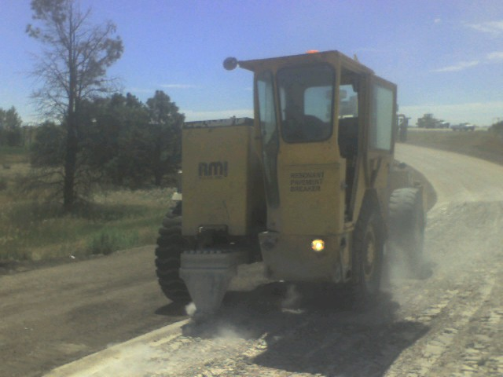
July 2010 - Colorado Use of Rubblization Continues to Grow 2010 is a “high water mark” year for the use of rubblization and asphalt overlay to rehabilitate deteriorated concrete pavement in Colorado. There are four rubblization projects currently under construction in Colorado. Two projects are on I-25, between Longmont and Ft. Collins, an additional project on US 85 - the Greeley Bypass (“O” to 5th Street), and Sterling Airport. The rubblization technology is proving to be a cost-effective process to rehabilitate older concrete pavements. (learn more)

BEST MANAGEMENT PRACTICES & SPECIFICATIONS FOR RUBBLIZING CONCRETE PAVEMENT (Revised - June 2009) Full Story
West Virginia Rubblization
FHWA Study on Rubblization
Edge drains: If installed properly, there really should be no maintenance for quite some time. The key is to make sure the exit drains on the side of the road stay clear of obstructions and the outside screens which keep small animals out and from building nests or something, are intact and secure. They have done numerous projects on I 25 and to my knowledge there have been little if any issues with edge drains, not to mention your state is quite arid and water issues other than melting snow in altitude type areas, is of little concerns with edge drains.

Costs: Also these findings, which in fact CDOT has – but they broke theirs down to per square yard. For remove and replace it was like $142 per square yard versus rubblizing with HMA overlay at $56 a square yard. Larry Labato from CDOT made those numbers public at his talk at the Rocky Mountain Asphalt Expo in 2008.

These numbers were from NAPA at a seminar we did in Texas in 2007
Road Rehab Rubblize with HMA overlay - $303,000 per lane mile
Unbonded PCC Overlay - $418,000 per lane mile
Remove and replace with pcc - $456,000 per lane mile

CONTACTS:
Matt Shinners – Antigo Construction, Wisconsin, www.antigoconstruction.com (715) 627-2222
Tony George – RMI Worldwide, LLC, www.resonantmachines.com, (816) 931-3111

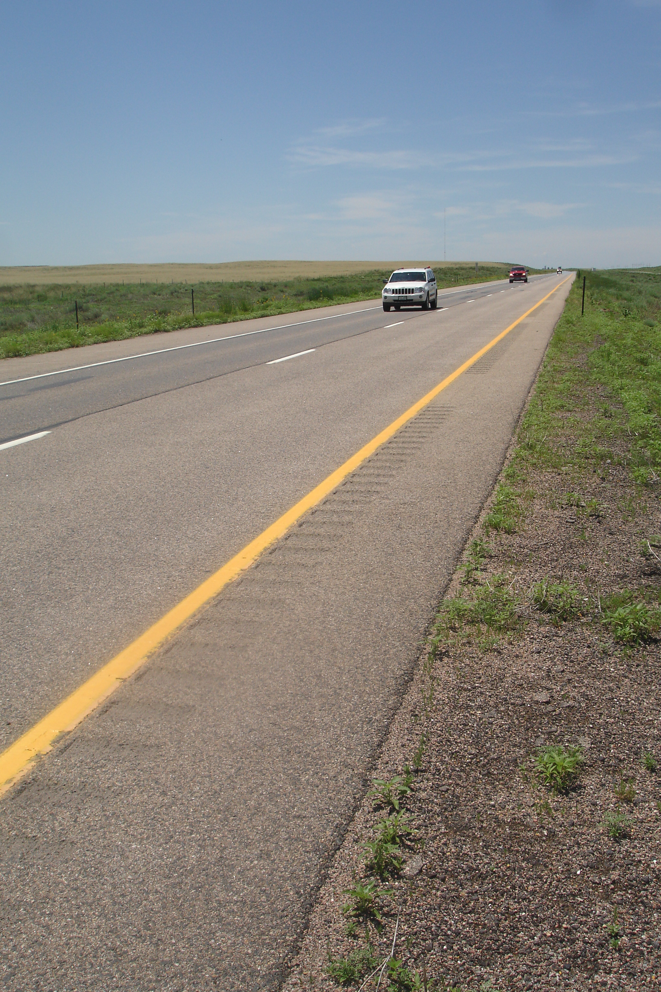
Photo: I-76, Sterling east, June 2009, rubblized concrete pavement plus HMA overlay, placed in 1999.
10 YEAR ANNIVERSARY OF RUBBLIZATION PLUS ASPHALT OVERLAY
Has it been 10 years already?? 2009 marks the 10 year anniversary of the initial rubblization plus asphalt overlay project in Colorado. Located on I-76, Sterling Interchange east 3 miles, the project consisted of a demonstration of both the resonant breaker and the multi-head breaker technology followed by 3-2” lifts of HMA. The pavement is performing well with no signs of rutting. The project was featured in The High Road - Summer, 1999. A project open house was conducted and CDOT Project Engineer Jeff Vickers commented that there are three advantages of rubblization plus asphalt overlay are reduced cost, shorter time of construction, and the ability to be performed under traffic.

RUBBLIZATION ON I-25 : 2007
MP 246 TO MP 249 (North of Mead)

