Colorado Asphalt Pavement Association
Technical Resources Library
Pavement Performance
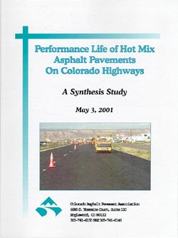
For more information give us a call at (303) 741-6150 or e-mail
office@co-asphalt.com
Presentation: "Asphalt Pavement Performance Measures" , by Joe Jehn, Colorado Transportation Commission Chairman, December, 2002 click here to view (Power Point Format, 700K).

