Colorado Asphalt Pavement Association
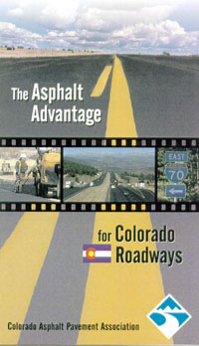 | Interested in learning about the quality improvements and advantages of asphalt for Colorado pavements? This 11 minute video explains the design and specification improvements that have occurred related to asphalt in recent years and describes the advantage over concrete related to the time of construction, initial construction cost, competitive life cycle cost, noise, smoothness and ease of maintenance.  To receive a complimentary copy, give us a call at (303) 741-6150 or e-mail office@co-asphalt.com

