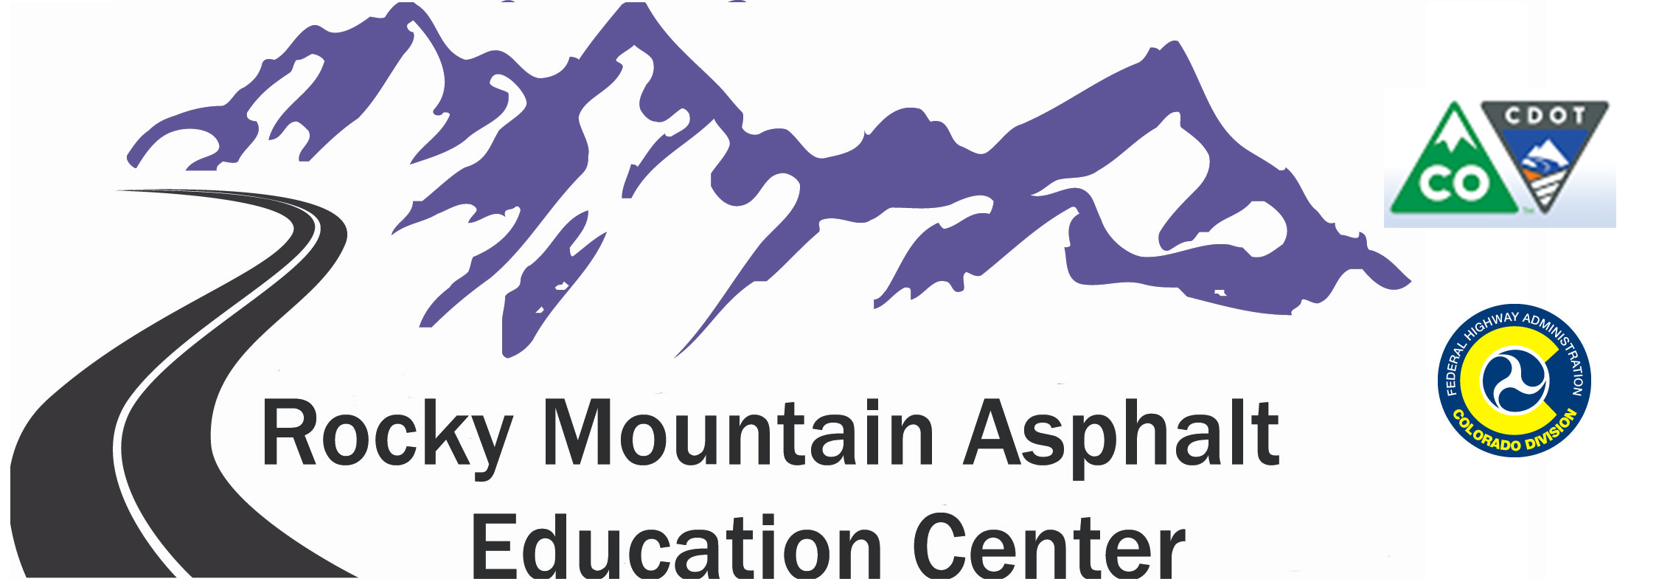

RELEASE OF LIABILITY

Laboratory for Certification of Asphalt Technicians (LabCAT)
And
RMAEC Introduction to PC/OA Testing

Training is to be provided by the Colorado Asphalt Pavement Association (CAPA). Upon my acceptance of such training, and as a condition of being accepted for such training, I acknowledge that the manufacture, preparation and use of asphalt pavement and materials related to the asphalt pavement industry involve a risk of physical injury to any individual undertaking such activity. I also acknowledge that the asphalt pavement industry involves use of extremely hot and hazardous materials which are difficult or impossible to completely contain or control, and which, likewise, cause an inherent risk assumed by a worker in the asphalt pavement industry. To the extent provided by law, the undersigned expressly assumes such risk and waives any claim he/she might state against CAPA because of physical injury incurred in said activities, even if such injury results from the alleged negligence of CAPA.

To the extent provided by law, I agree to hold CAPA harmless for any negligence, carelessness or intentional or non-intentional acts which result in my injury or someone else’s injury.

The undersigned acknowledges that all his/her future work in asphalt pavement operations and safety must be based upon the undersigned’s own experience and judgement and that no claim will be made against CAPA arising in any way out of the training or certification it provides to the undersigned except as expressly set forth in this Agreement.

To the extent provided by law, the undersigned further agrees to hold CAPA, its officers, directors and employees harmless from and against all claims, liabilities, causes of action, and other legal proceedings, including reasonable attorneys’ fees, which may be brought by third parties in any way arising out of or connected with or resulting from my future activities in the asphalt pavement industry.

The undersigned further acknowledges and agrees that CAPA has made and disclaimed all express or implied warranties about the training or certification provided to the undersigned. In undertaking training and certification with CAPA, the undersigned is relying solely upon his or her own judgement or that of his or her employer that such training or certification may be helpful to his/her professional development, and is not relying on any representation made by CAPA as to the efficiency or completeness of said certification and training.

This agreement shall be effective and binding upon the parties hereto. The parties hereto acknowledge having read and understood this agreement.

6880 S. Yosemite Ct. Suite 110Centennial, CO 80112
Phone (303) 741-6148 ext. 154Fax (303) 741-6146
Email: rmaec@co-asphalt.com

Revised November 2016

